Type the title of paper and only capitalize first word
First author¹, Second author¹, Third author²
1
2

Abstract
The article should have a self-contained, citation-free abstract that succinctly summarize the objectives, the methodology employed, the main findings and the principal results of the study. Also, abstract should present a brief and factual account of content and conclusions of the paper. Do not include figures, tables, equations or references to other parts of the paper or to the reference listing at the end. Do not use any subheading or point list within the abstract. Also, non-standard or uncommon abbreviations should be avoided, but if essential they must be defined at their first mention in the abstract itself. Each article should contain an abstract section within 150-200 words in a single paragraph.

Keywords: Keyword 1, Keyword 2, Keyword 3… (Provide 4-6 keywords separated by comma)

Introduction
State the objectives of the work and provide an adequate background information to allow the results of the paper to be understood and evaluated. It should clearly explain the nature of the topic, previous work, purpose, and contribution of the paper. Please avoid a detailed literature survey or a summary of the results. Instead, Introduction should state the reason for the work, with brief reference to previous work on the subject. This section should be succinct, with no subheadings unless unavoidable.
Papers should be headed by a concise but informative title that clearly reflects the subject of the paper. Paper should neither been published before nor be under consideration for publication in another journal or conference. It is important that the grammar and spelling of your paper is correct. Define abbreviations and acronyms the first time they are used in the text, even after they have already been defined in the abstract. Abbreviations should be used consistently throughout the text.

Organization and structure
Texts should be written in Microsoft Word format. The text should be in two-column format. Keep the layout of the text as simple as possible. Divide your article into clearly defined and numbered sections. Subsections should be numbered 1.1 (then 1.1.1, 1.1.2, ...), 1.2, etc. The paper must include the following: Abstract, Introduction, Main Text, Conclusion, References.

Figures and Tables
Figures and tables should be numbered properly with descriptive titles. They have to be numbered consecutively and appear by order for ease of discussion and reference in the text. The figure and table caption shall be placed below the figure. Use Times New Roman 10 pt Italic font for captions. If the figure does not fit in one column, two column wide figures are allowed. However, text in columns should not break when inserting wide figures/tables (put such figures/tables on top or bottom of page).
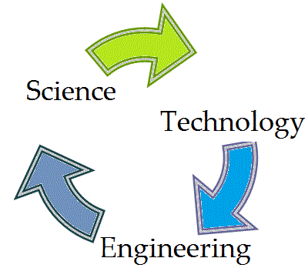
Fig. 1. An example of a figure

Table should be prepared using table tool within the Microsoft word and cited consecutively in the text (for example, formatting requirement has been summarized in the Table 1). If the table do not fit in one column, two column wide tables are allowed. However, text in columns should not break when inserting wide figures/tables (put such figures/tables on top or bottom of page).

Table 1. An example of a table
An example of a column heading | Column A (t) | Column B (T)
And an entry | 1 | 2
And another entry | 3 | 4
And another entry | 5 | 6

Mathematical Expressions
Mathematical expressions have to be numbered consecutively for ease of discussion and reference in the text. In the text an equation is referenced by its number in parenthesis, e.g. "... from Eq. (1) follows ...". The use of SI units and their standard symbols and abbreviations is encouraged.

$f\left(x\right)=a_{0}+\sum_{n=1}^{∞}{\left(a_{n}\cos{\frac{nπx}{L}}+b_{n}\sin{\frac{nπx}{L}}\right)}$ (1)

Conclusion
Conclusion section contains the most important outcome of article that have been drawn from the results and subsequent discussion. Besides, conclusion might contain some future research directions.

References
All references should be cited in the text and vice versa. References must be numbered consecutively. Citations in the text should be identified using numbers in square brackets (for example, “The theory was first put forward in 1986 [1]” or “…as discussed in many reports [2]-[5]”). The author(s) are encouraged to use reference managers such as Mendeley, Endnote, Word References, etc. Examples of references style is listed below:

Periodicals (Journals):
J. K. Author, “Name of paper,” Title of Periodical, vol. x, no. x, pp. xxx-xxx, Abbrev. Month, year.

Conferences and Proceedings:
J. K. Author, “Title of paper,” in Name of Conference, location of conference is optional, Month and day(s) if provided year, pp. xxx-xxx.

Books:
J. K. Author, “Title of chapter in the book,” in Title of Published Book, edition (if not first), City of Publisher, Country: Abbrev. of Publisher, year, pp. xxx–xxx.

Corresponding author: Author (e-mail address) © 2026 The Author(s). This work is licensed under a Creative Commons Attribution 4.0 International License.

